2280601517_Nguyễn Khoa
https://github.com/NguynK04/J2EE_2280601517_NGUYENKHOA.git

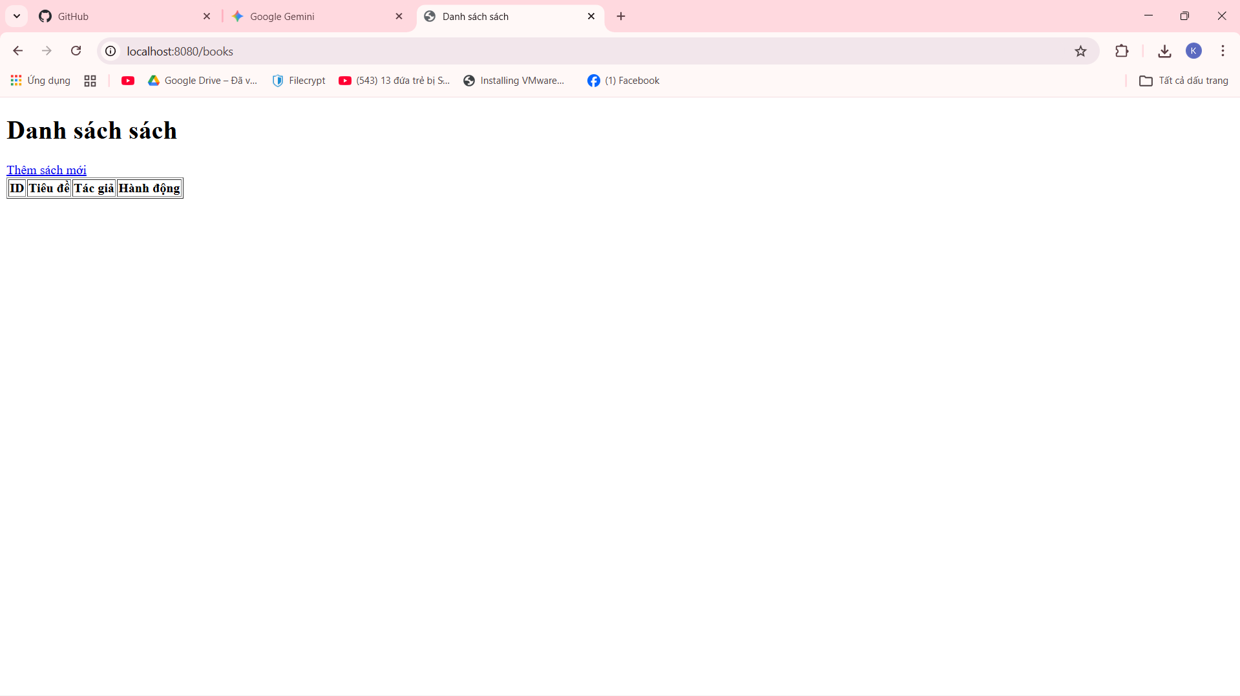

Them
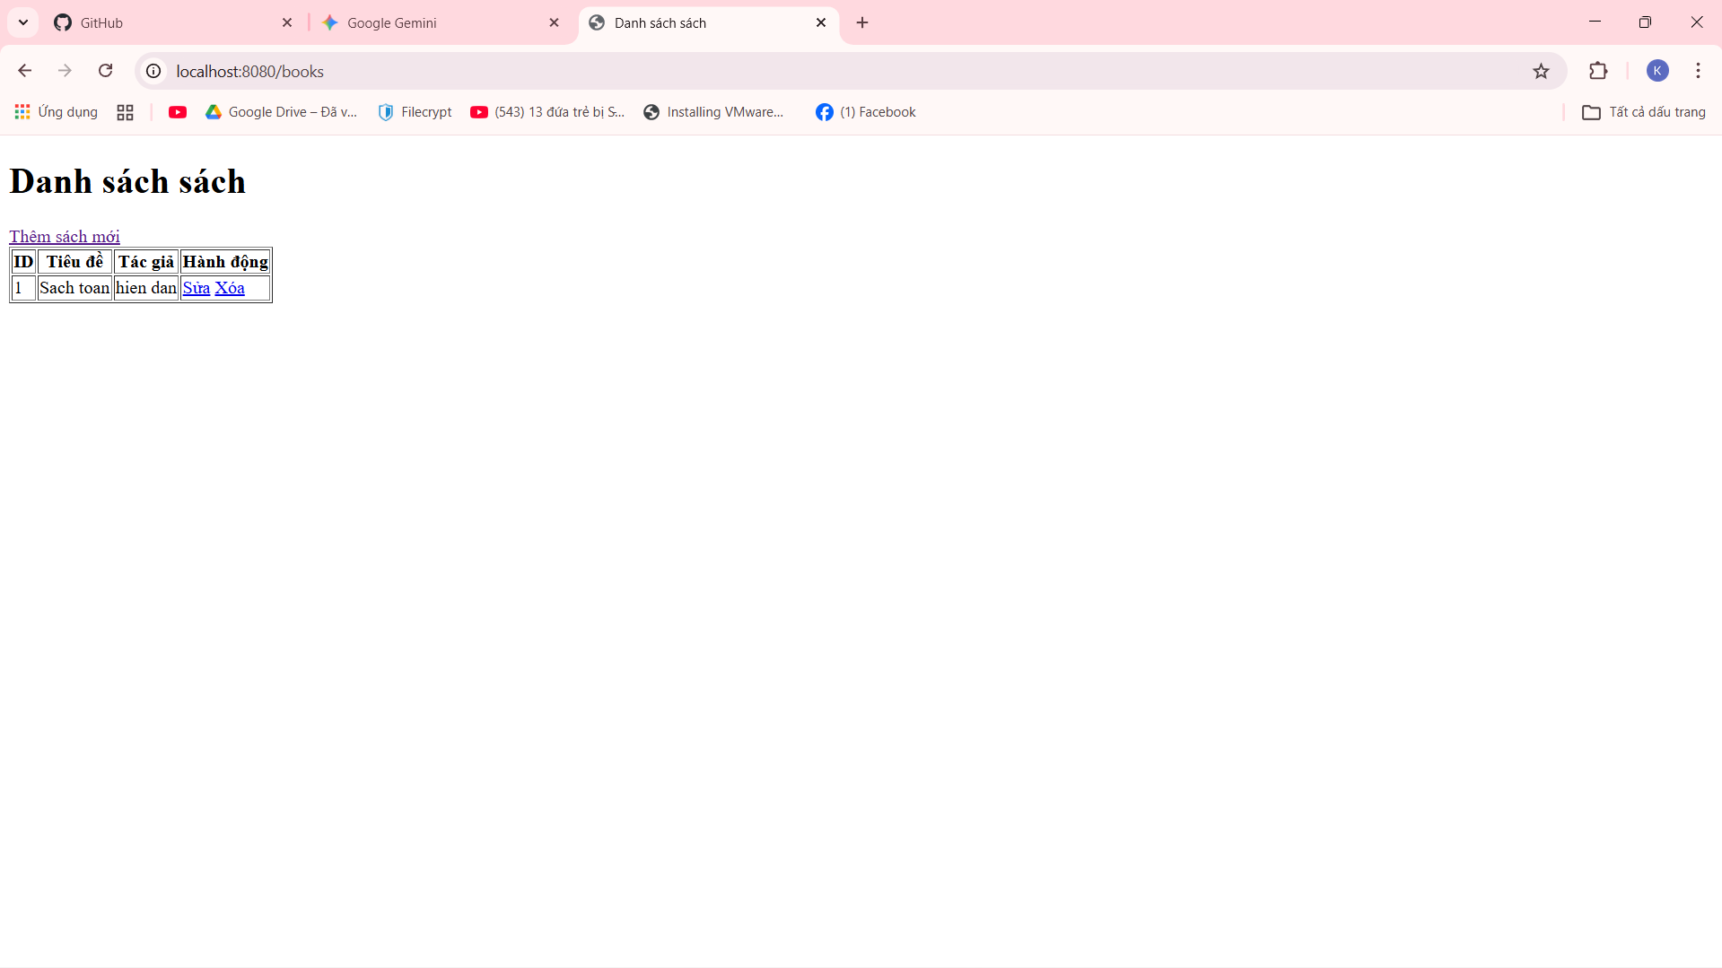

Sửa

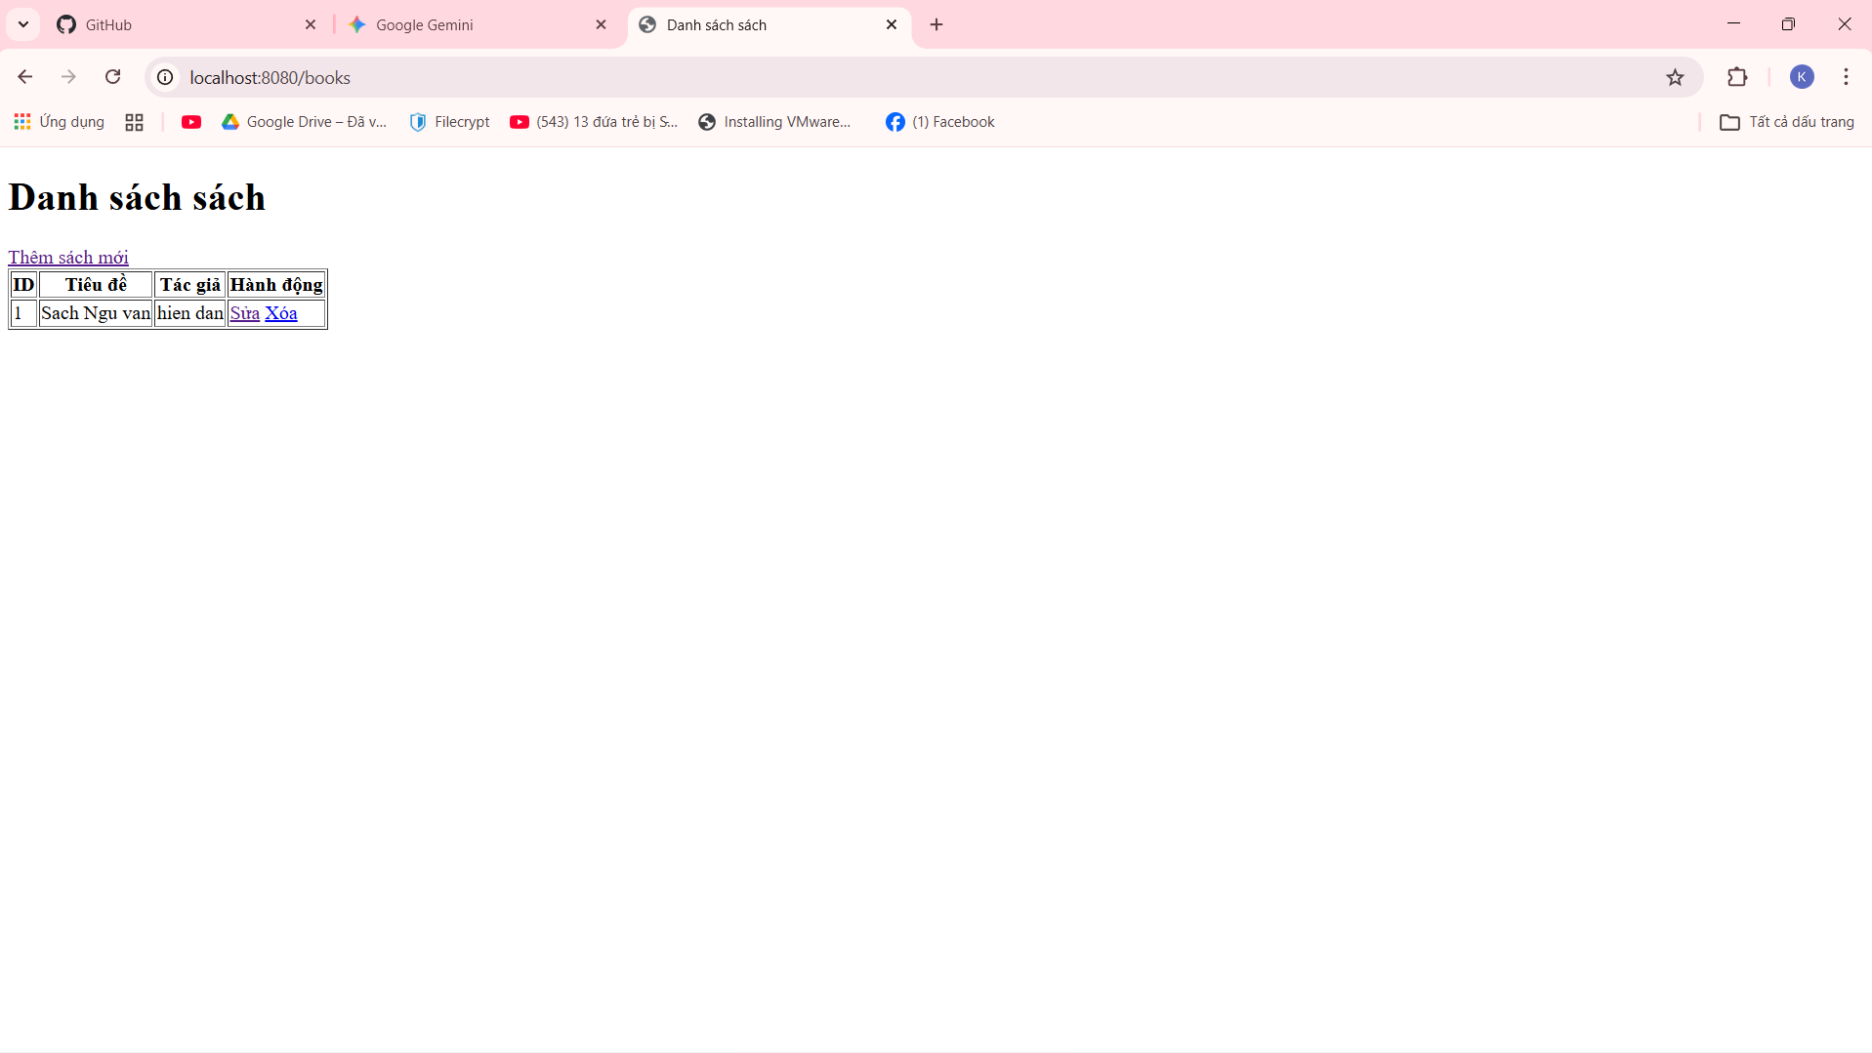
Xóa

